Report Scaffold

Reasoning
Firstly, my algorithm gets the number of available servers, and limits it to n if k>n. The input array is then divided into k sublists as evenly as possible, so their sizes differ by at most 1. Each sublist is recursively sorted by using the same merge_sort function. The base case occurs when the sublist contains only one element. Subsequently, merge_sorted_lists is used to combine the sorted sublists. In the merge_sorted_lists, I merge sort the sublists sequentially: the first list becomes the initial merged result, then each sublists remained is merged with current result using standard two pointer merge technique.

Evidence of Testing

Test Case | Proof
Already sorted | 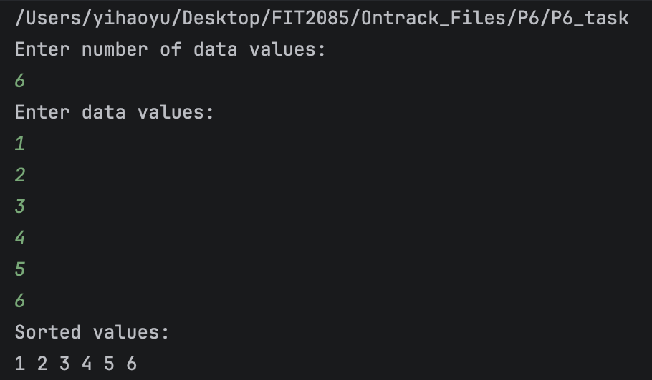
Reserve order | 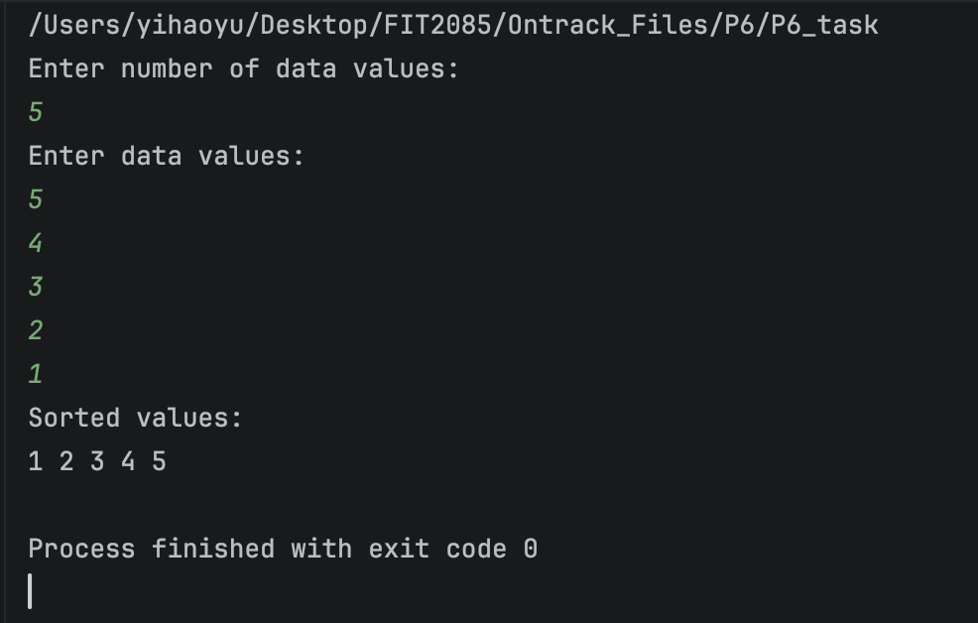
Duplication | 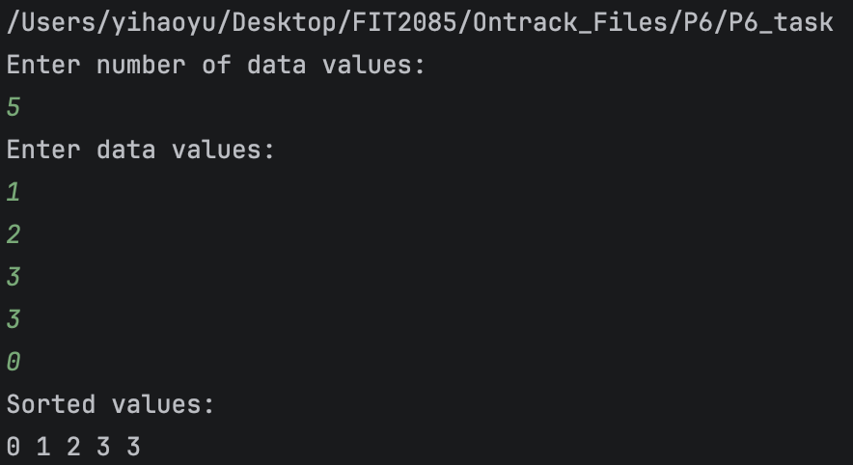
Negative numbers | 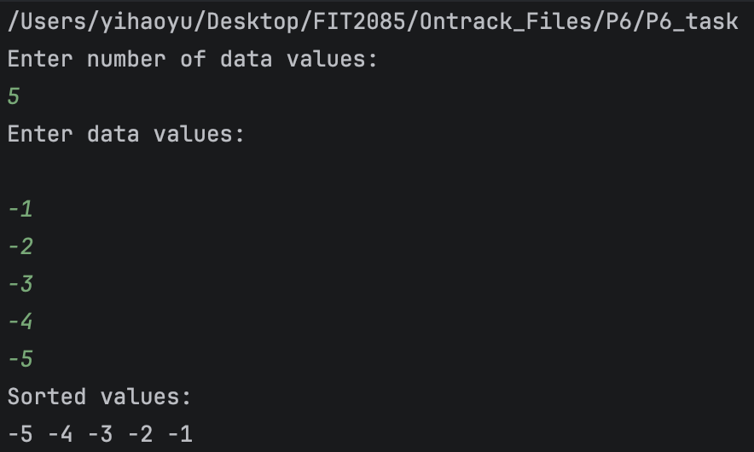

Time Complexity Analysis
Let n be the number of elements and k be the number of available servers at a recursive call. The input is divided into approximately equal sublists of size n/k.
My merging method is sequential. After copying the first sublist, the second merge processing approximately 2n/k elements, the third merge processing approximately 3n/k elements and this continues until the final merge processing n elements. Therefore:
T(n, k) = n/k + 2n/k + … + k = n/k * (1+k)*k/2 = n * (1+k) /2
= O (nk)

At every recursion level, it would cost O(nk+n) = O(nk) for splitting and merge_sorted_list.

We have log_{k}n recursion levels, therefore:
O(nk)*O(log_{k}n) = O (nk log_{k}n)

Worst case: k=n
O(nk log_{k}n) = O(n²)
Best case: k=2
O(nk log_{k}n) = O(nlogn)

Word Count
This document contains 252 words.

